PROJECT AND TEAM INFORMATION

Project Title
(Try to choose a catchy title. Max 20 words).
DocuCompiler: A Lightweight Full Stack NLP System

Student / Team Information
Team Name: | zealous
Team member 1 (Team Lead)  Name: Paras Rawal  Student Id: 230111703  Email: parasrawal117@gmail.com  University roll no: 2319207 | 
Team member 2
Name: Ishan pant
Student Id: 230111630
Email: ishanpant57@gmail.com
University roll no: 2318894
Team member 3  Name: Paras pant  Student Id: 23011046  Email: paraspant181@gmail.com  University roll no: 2319208 | 
Team member 4  Name: Shobhit joshi  Student Id: 23011783  Email: joshishobhit1705@gmail.com  University roll no: 2319583 | 

PROPOSAL DESCRIPTION (10 pts)

Motivation (1 pt)
(Describe the problem you want to solve and why it is important. Max 300 words).
The exponential growth of digital documents in research, business, and academia has made efficient information extraction increasingly challenging. Users are often required to process lengthy PDFs, reports, and articles under time constraints, leading to cognitive overload and reduced productivity. While modern transformer-based large language models achieve impressive performance in summarization and question answering, they typically require high computational resources, GPU acceleration, and cloud-based deployment.
Such systems are impractical for low-resource environments, offline usage, and CPU-based deployments. Many existing platforms prioritize model scale over efficiency, resulting in increased inference costs and limited accessibility. There is a need for a lightweight, modular, and scalable NLP platform that can perform long-document summarization, keyword extraction, and document-based question answering without relying on large-scale infrastructure.
The proposed system addresses this gap by combining extractive methods such as TextRank with small abstractive models like T5, along with embedding-based retrieval using all-MiniLM-L6-v2. The goal is to demonstrate that efficient architecture design can achieve practical performance on CPU-based systems while maintaining interpretability and scalability.

State of the Art / Current solution (1 pt)
(Describe how the problem is solved today (if it is). Max 200 words).
Document summarization techniques are broadly categorized into extractive and abstractive approaches. Extractive methods, including TextRank and TF-IDF-based scoring, rank and select important sentences from the original text. These methods are computationally efficient and interpretable but lack true abstraction capability.
Abstractive summarization gained prominence with transformer-based models such as BART and T5, which use encoder-decoder attention mechanisms to generate fluent, human-like summaries. Despite strong benchmark performance, these models face limitations in handling long documents due to quadratic attention complexity and high resource requirements.
For document-level question answering, retrieval-augmented approaches have become standard. Systems generate embeddings, store them using vector search tools like FAISS, and apply lightweight QA models such as DistilBERT to extract answers.

Project Goals and Milestones (2 pts)
(Describe the project general goals. Include initial milestones as well any other milestones. Max 300 words).
Main Goals
- Design a compiler-style pipeline for document processing
- Implement lexical and syntactic style processing for text
- Generate structured intermediate representations of documents
- Produce concise summaries using extractive and lightweight abstractive techniques
- Enable document-based question answering using semantic retrieval
Milestones
Week | Milestone
Week 1–2 | Requirement analysis and compiler-model mapping
Week 3 | Design document processing pipeline (Lexical, Syntax, Semantic phases)
Week 4 | Implement text extraction and tokenization (Lexical Analysis)
Week 5 | Sentence structure modeling and chunking (Syntax Analysis)
Week 6 | Meaning extraction, keyword detection (Semantic Analysis)
Week 7 | Intermediate Representation and summary generation
Week 8 | Question-answer module integration
Week 9 | Frontend interface development
.

Project Approach (3 pts)
(Describe how you plan to articulate and design a solution. Including platforms and technologies that you will use. Max 300 words).
Compiler-Based System Design
This project models document processing similar to a compiler pipeline:
Compiler Phase | Equivalent NLP Task | Tools/Methods
Lexical Analysis | Tokenization, cleaning, stopword removal | NLTK / SpaCy
Syntax Analysis | Sentence segmentation, structure modeling | SpaCy / rule-based parsing
Semantic Analysis | Keyword extraction, topic detection | TF-IDF, TextRank
Intermediate Representation | Chunk embeddings / sentence vectors | Sentence Transformers
Optimization | Redundancy removal, sentence ranking | Similarity scoring
Code Generation | Final summary creation | TextRank + T5-small
Technologies Used
Component | Technology | Purpose
Backend | Python (FastAPI) | API and pipeline control
NLP Processing | NLTK, SpaCy, Transformers | Text analysis
Summarization | TextRank + T5-small | Lightweight summarization
Embeddings | all-MiniLM-L6-v2 | Semantic representation
Vector Storage | FAISS | Fast retrieval
Database | SQLite | Store documents, summaries, history
Frontend | HTML, CSS, JS / React | User interaction
System Workflow
- User uploads a document
- Text is extracted and passed through Lexical Analysis
- Cleaned tokens are grouped into sentences (Syntax Phase)
- Important terms and meanings identified (Semantic Phase)
- Sentences converted into embeddings (Intermediate Representation)
- Ranking and optimization remove redundancy
- Final summary generated
- User can ask questions; relevant chunks retrieved via FAISS

System Architecture (Entity Relationship Diagram)(2 pts)
(Provide an overview of the system, identifying its main components and interfaces in the form of a diagram using a tool of your choice).
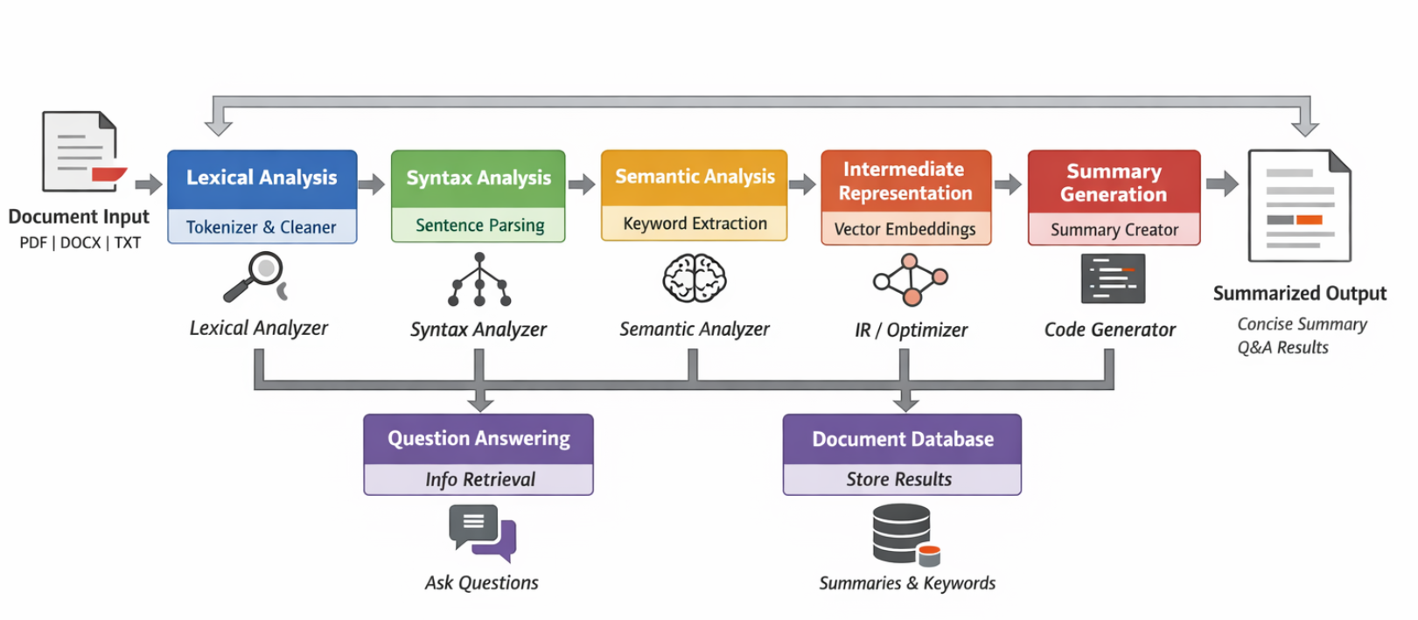

Project Outcome / Deliverables (1 pts)
(Describe what are the outcomes / deliverables of the project. Max 200 words).
- A working compiler-inspired NLP pipeline
- Document summarization system for PDFs, DOCX, and TXT files
- Keyword extraction and topic detection module
- Retrieval-based document question answering feature
- Web interface for document upload and interaction
- Documentation including system design, pipeline explanation, and architecture diagrams
- This project demonstrates the practical application of compiler design concepts beyond programming languages and into intelligent document processing.

Assumptions
( Describe the assumptions ( if any ) you are making to solve the problem. Max 100 words )
- Users upload text-based documents in supported formats
- Documents are primarily in English
- System runs on CPU-only environments
- Internet is not required for processing once models are downloaded

References
(Provide a list of resources or references you utilised for the completion of this deliverable. You may provide links).
- Phases of a Compiler (lexical, syntax, semantic, etc.)
https://www.geeksforgeeks.org/compiler-design/phases-of-a-compiler/
- Compiler Design Tutorial (basic & advanced topics)
https://www.tutorialspoint.com/compiler_design/index.htm
- Slide Overview of Compiler Design & Phases
https://www.slideshare.net/slideshow/introduction-to-compiler-design-and-phases-of-compiler/270595653

Text Summarization & NLP References (Methodology)
- Text Summarization in NLP (extractive vs abstractive)
https://www.geeksforgeeks.org/nlp/text-summarization-in-nlp/
- TextRank Explained (graph based summarization)
https://blog.fastforwardlabs.com/2021/09/22/automatic-summarization-from-textrank-to-transformers.html
- Text Summarization Using TextRank (tutorial with implementation)
https://www.analyticsvidhya.com/blog/2018/11/introduction-text-summarization-textrank-python/
- Academic Study: Document Summarization with TextRank
https://www.researchgate.net/publication/320855773_Document_Summarization_using_TextRank_and_Semantic_Network

